**Dashboard**: <https://public.tableau.com/views/TrendingVideosdataset/Dashboard12?:language=en-US&publish=yes&:display_count=n&:origin=viz_share_link>

**Insights**

**1: Is the count of views is the sole factor that makes videos trend. Or do the count of likes, dislikes, and comments equally impact their position?**

**a) Description of Visualization 1:** A Line Chart graph is plotted to compare the counts of Views, Likes, Dislikes, and Comments to see a similarity in trend. The magnitude will obviously vary, but if all the factors trend similarly, it is a reason to believe that all factors have a contribution to making a video popular.

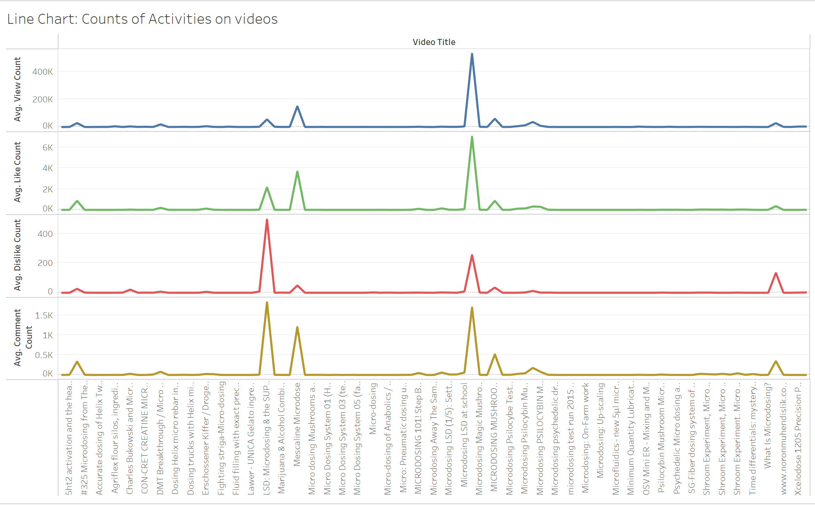

**b) Insights Gained:** As seen from the Visualization, the count of Views, Likes, Dislikes, and Comments follow the same trend, leading to the observation that not just the number of views but all the above activities contribute equally to making a video trend on YouTube.

If either of these activities was trending inconsistent from the others, it would have meant that activity does not play a role in making a video trending. For example, if there were a set of videos that received a huge count of views and likes, but had very low dislikes relatively and videos with fewer likes had greater dislikes, that would have led to an insight that only videos with the greater share of likes will trend on YouTube. But that is not the case here. We can see videos with a high count of likes also generating a lot of dislikes relatively. That means a video can have its share of likes and dislikes and still trend on YouTube. In other words, both factors- likes and dislikes, hold similar relevance in this context.

**2: Is there any particular channel or category or a combination of the two factors that is specifically generating more trending videos.**

**a) Description of Visualization 2:** In the Packed Bubbles, each Bubble represents a different YouTube channel. Each color represents the Category of the videos that the channel focuses on, while the size of the bubbles is proportional to the count of trending videos generated by the channel.

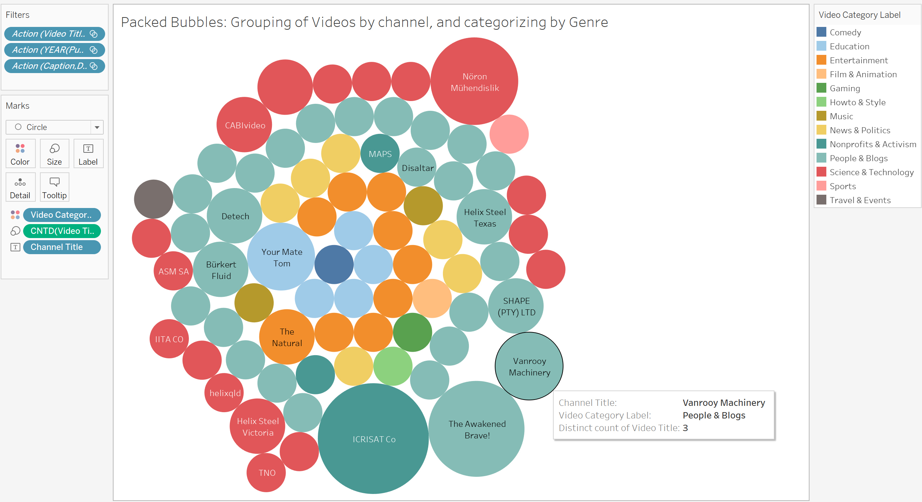

**b) Insights Gained:** From this visualization, we can see which channels have generated more trending videos, classified by Categories to draw some notable insights.

Firstly, each channel is resorting to a certain genre of videos rather than mixing up different categories. Secondly, we get to observe the most preferred video categories by content creators. Here, most channels prefer to make videos on ‘People & Blogs’, and ‘Science and Technology’ over other categories. Hence, these categories can be considered the most trending categories.

Thirdly, while the category is playing a huge role, the quality of the content and novelty factor also coexist here. This is demonstrated as the highest number of trending videos from a single channel are coming from a category that is pursued by only three channels, that is, videos based on ‘Nonprofits & Activism,’ from the channel ‘ICRISAT Co’.

**3: To what extent does the time of the video release impact its trend at present?**

**a) Description of Visualization 3:** A Side-by-side Bar Graph is plotted to divide the videos by their release date. The intent is to observe and see if the relatively newer videos tend to trend better than older videos, or vice versa. For better visualization, each month is represented by a different color.

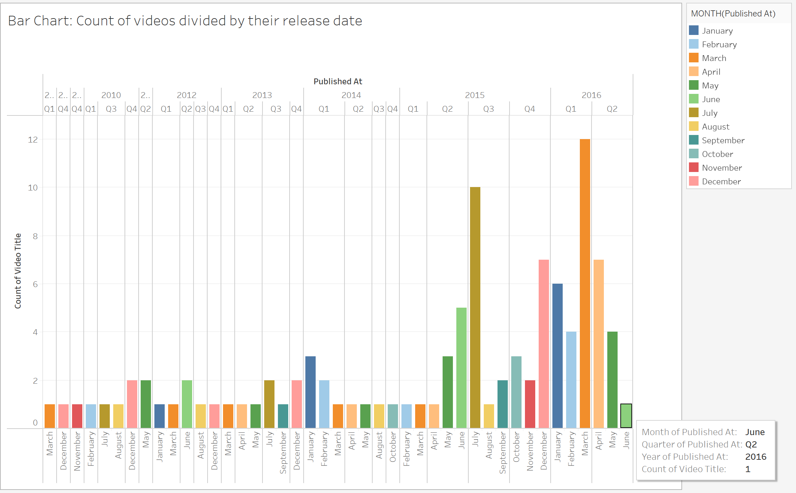

**b) Insights Gained:** From the visualization, the conclusion drawn is that the latest videos trend better than old videos as it is seen that most of the trending videos are those released in recent time periods.

The old views may possibly have more view count, but evidently, videos released recently have a better chance of trending. The most plausible explanation for this observation is that newer videos are generating activity (views, likes, dislikes, comments) at present which is why they are trending now. This reassures us of a crucial insight that contemporary actions play a greater role than cumulative actions to make videos trend.

**4: Find out if the length of a video has a vital role in determining its trending position. Or viewers will still spare time to watch the video if it is a convenient watch, based on factors such as video definition or the availability of captions?**

**a) Description of Visualization 4:** The Visualization is plotted in the form of Circle Views where each circle represents the length of each video. The color of the circle denotes the definition, and the pages further divide the videos based on the availability of Captions.

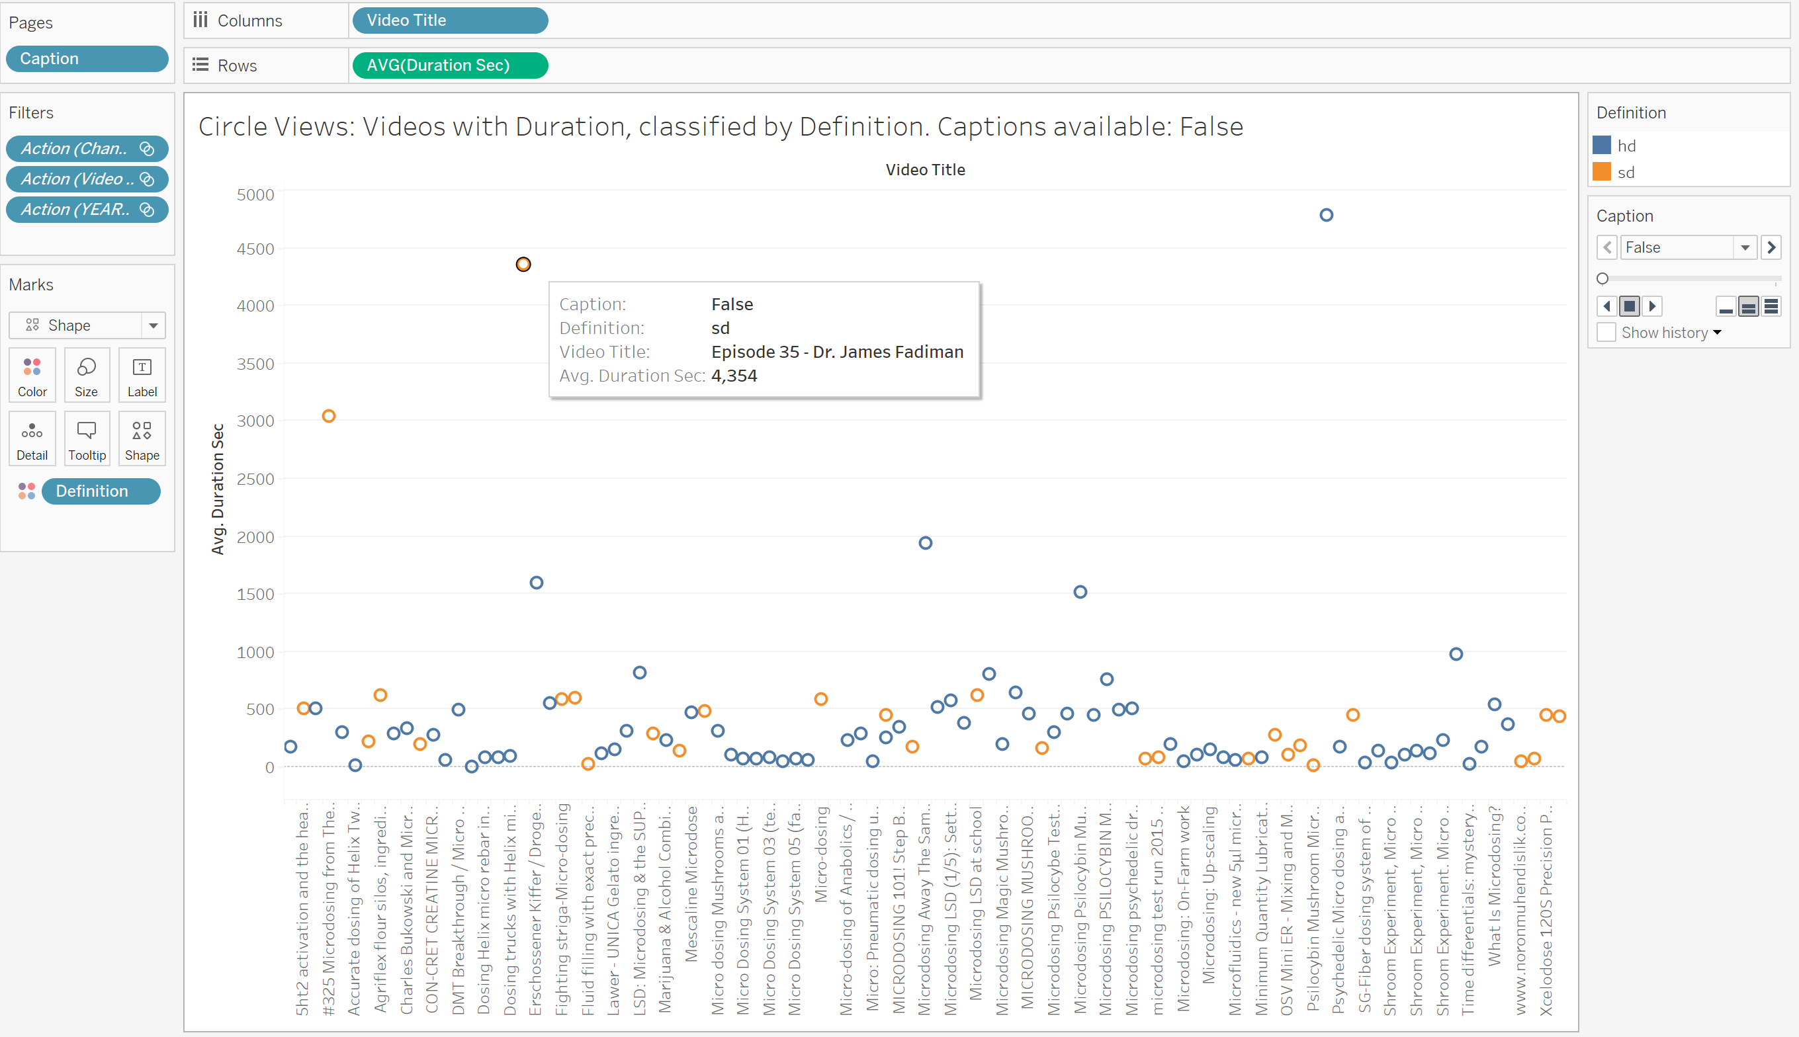

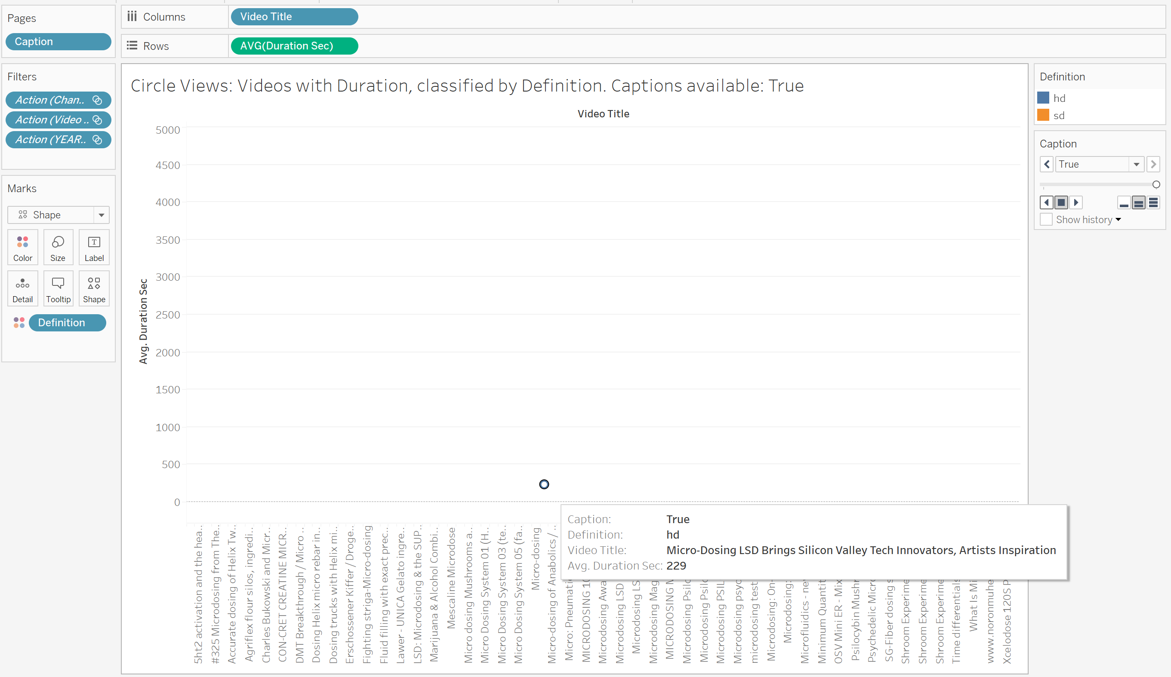

**b) Insights Gained:** From this visualization, the prime observation made is that videos with shorter lengths have a much greater chance of trending as nearly all videos from the dataset have an average duration period of fewer than 1000 seconds, with the majority of the points closer to 0 seconds.

On the other hand, two surprising insights are drawn. There are more videos with Standard definition than with High definition, and there is only one video with the option to enable Captions for the video. This leads to the conclusion that auxiliary factors such as Video Quality and Availability of Captions do not have a noticeable role in the video’s potential to trend.